Predictive and Prescriptive Profit Intelligence for Restaurant Channel- Mix Strategy:
A Case Study of SkyCity Auckland Restaurants & Bars

Vipsa Patel
Data Analyst Intern, Unified Mentor

Abstract

Restaurants that sell through several channels at once—walk-in dining, Uber Eats, DoorDash, and their own delivery staff—face a problem: A static monthly report cannot answer the following: every channel pulls profit in a different direction, and the right mix depends on commission rates, delivery costs, and order volumes that move over time. This paper describes a profit intelligence system built for SkyCity Auckland’s restaurant and bar portfolio that goes beyond descriptive reporting into prediction and prescription. Using a panel of 1,696 restaurant-level records, three regression models were trained to estimate total net profit from channel shares, cost rates, and order-level features. A Gradient Boosting model produced the strongest raw accuracy (R² = 0.9732, MAE = $704). In contrast, the Random Forest model (R² = 0.9599, MAE = $834) was carried forward into production because its ensemble structure makes it straightforward to derive an empirical prediction interval. Its performance is less sensitive to how the training data happens to be split. The trained model feeds three decision-support layers built on top of it: a what-if scenario simulator that tests channel mix, commission, and demand shocks against a live baseline; a constrained optimizer (SLSQP) that recommends a profit-maximizing channel allocation subject to business rules such as a minimum in-store share; and a sensitivity module that ranks cost drivers by dollar impact per one percentage change. On the current data, the optimizer recommends moving away from heavy reliance on Uber Eats—currently 48.7% of order share—toward a more balanced mix anchored by in-store sales, projecting a 45.4% profit uplift over the current average allocation. The analysis is delivered through a five-page Streamlit dashboard so that it is something a manager can click through rather than something that only lives in a notebook. The paper closes with an honest look at a data-leakage risk in the current feature set—channel-share variables are built from the same revenue columns used to construct the profit target—and what a future version of the model should do differently.

1. Introduction

Restaurant operators who sell across in-store, Uber Eats, DoorDash, and their own delivery fleet are, in effect, running four small businesses with four different cost structures under one roof. In-store sales carry no commission but need staff and space. Aggregator orders bring in volume, but the platform takes a cut before the restaurant sees a cent. Self-delivery sits in between: no commission, but the restaurant now owns the logistics risk. A shift of a few percentage points in how orders are split across these channels, or a change in the commission rate an aggregator charges, can move monthly profit by thousands of dollars—and most restaurant groups only find this out after the fact, once the numbers have already landed on a financial statement.

SkyCity Auckland’s restaurant and bar division already tracks all of this data: revenue by channel, cost rates, delivery radius, order volume, and more, broken down across 1,696 restaurant-cuisine-segment combinations. What was missing was a way to turn that historical data into forward-looking answers. If Uber Eats commission rose by five points, what would that do to profit? Is the current channel mix actually the best one available, or is there a better allocation for the business that hasn’t been tried yet? Which single input—OPEX rate, order volume, or commission—deserves the most attention when negotiating with a delivery partner or setting a budget?

This project builds a system that answers those questions directly. It combines three components that are usually kept separate: a predictive model that estimates net profit from channel mix and cost inputs, a scenario engine that lets users test hypothetical futures against that model, and an optimization layer that searches for the best available channel allocation under real business constraints. All three sit inside a single Streamlit dashboard, so the output is not a static PDF but something a restaurant manager or executive can open, adjust, and interrogate on their own.

2. Related Work

The shift from descriptive dashboards to predictive and prescriptive analytics has been well documented across supply chain and operations research, though its application to restaurant channel economics is less well documented. Ensemble trees are methods such as Random Forest (Breiman, 2001) that remain a common default for tabular business data of this kind because they handle non-linear interactions between cost rates and channel shares without requiring the analyst to specify those interactions by hand and because they degrade gracefully in the presence of noisy or correlated inputs—both properties that matter for a dataset built from real operational reporting rather than a controlled experiment.

Prescriptive analytics adds a second layer on top of prediction: once a model can estimate an outcome, the natural next question is what input configuration produces the best outcome, subject to constraints that reflect how the business actually has to operate. Sequential Least Squares Programming (SLSQP) is a standard choice for this kind of constrained, nonlinear optimization problem because it can handle both equality constraints—such as channel shares summing to one—and inequality constraints, such as a minimum in-store share a business wants to preserve for reasons outside the model’s view, like staffing or brand presence.

Where this project differs from a purely technical modeling exercise is in its decision to expose all three layers—prediction, scenario testing, and optimization—through a single interactive interface for non-technical users. Rather than producing a model and a set of static findings, the goal was a tool that a manager could return to every month as inputs change, in the same spirit as decision-support systems built for supply-chain reallocation problems, where the value comes as much from interactivity as from the underlying model’s accuracy.

3. Dataset & Features

3.1 Dataset schema
The analysis is built on operational data covering 1,696 restaurant records across SkyCity Auckland’s portfolio, spanning eight cuisine types (burgers, pizza, Indian, Chinese, Japanese, Thai, chicken dishes, and kebabs/Mediterranean), four business segments (cafe, QSR, full-service, and ghost kitchen), and four Auckland subregions (North Shore, South Auckland, West Auckland, and CBD). Each record captures a full month of activity for a restaurant, broken down across four sales channels: in-store dining, Uber Eats, DoorDash, and self-managed delivery.
The key fields are summarized below.

Category | Fields
Identifiers | RestaurantID, RestaurantName, CuisineType, Segment, Subregion
Volume | Monthly Orders, AOV, GrowthFactor, per-channel order counts
Revenue | InStoreRevenue, UberEatsRevenue, DoorDashRevenue, SelfDeliveryRevenue
Cost structure | COGSRate, OPEXRate, CommissionRate, DeliveryCostPerOrder, DeliveryRadiusKM
Profit | InStoreNetProfit, UberEatsNetProfit, DoorDashNetProfit, SelfDeliveryNetProfit, TotalNetProfit
Channel mix | InStoreShare, UE_share, DD_share, SD_share
Across the full portfolio, the data shows $77.7 million in gross revenue and $7.87 million in net profit, for a blended margin of 10.4% and an average order value of $38.52. Channel-level revenue is heavily weighted toward Uber Eats, which accounts for 39.6% of revenue, followed by DoorDash (21.6%), self-delivery (20.4%), and in-store (18.4%)—a split that, as discussed in Section 5, is itself one of the findings the optimizer reacts against.

3.2 Feature engineering and processing
Three categorical fields—CuisineType, Segment, and Subregion—were label-encoded into numeric form so they could be used by all three candidate models. Two interaction terms were engineered to let the model capture cost effects that only appear when a channel is actually used at scale: CommissionRate multiplied by each aggregator’s order share (Commission_UE, Commission_DD) and DeliveryCostPerOrder multiplied by self-delivery share (DeliveryCost_SD). These terms matter because a high commission rate has no profit impact on a restaurant that sends almost no orders through that channel, and a linear model without the interaction term would not be able to represent that.

The final feature set passed to each model was the following: InStoreShare, UE_share, DD_share, SD_share, CommissionRate, DeliveryCostPerOrder, DeliveryRadiusKM, GrowthFactor, AOV, MonthlyOrders, COGSRate, OPEXRate, the two commission interaction terms, DeliveryCost_SD, and the three encoded categorical fields—eighteen features in total, predicting TotalNetProfit. Rows with missing values in any of these fields were dropped before training.

4. Methodology

4.1 Predictive modeling for net profit
Three regression models were trained and compared on an 80/20 train-test split (1,356 training rows, 340 test rows): Linear Regression as an interpretable baseline, Random Forest Regression, and Gradient Boosting Regressor. All three were trained on the same eighteen-feature set described above, with identical train-test splits (random_state = 42) to keep the comparison fair.

The three models were evaluated on the held-out test set using Root Mean Squared Error (RMSE), R², and Mean Absolute Error (MAE). Results are summarized in Table 2.

Model | R² | RMSE | MAE
Linear Regression | 0.8873 | $1,904 | $1,307
Gradient Boosting | 0.9732 | $928 | $704
Random Forests (selected) | 0.9599 | $1,135 | $834

Gradient Boosting produced the best raw accuracy of the three, edging out Random Forest on every metric. Random Forest was nonetheless selected as the production model behind the live dashboard for two practical reasons rather than a raw-accuracy argument. First, because a Random Forest is an ensemble of independently trained trees, the spread of predictions across its estimators gives a natural, model-native way to express uncertainty around a single prediction—something the dashboard uses directly (Section 4.2). Second, Random Forest’s bagging approach tends to be more stable across different train-test splits and small changes in the underlying filtered data than boosting is, which matters in a dashboard where a user can apply filters (by cuisine, segment, or subregion) that change the training data on the fly. The gap between the two models is real and is reported honestly in Table 2 and again in the Limitations section; a future iteration of this system could reasonably adopt Gradient Boosting as the default and layer a separate uncertainty-quantification method on top of it.

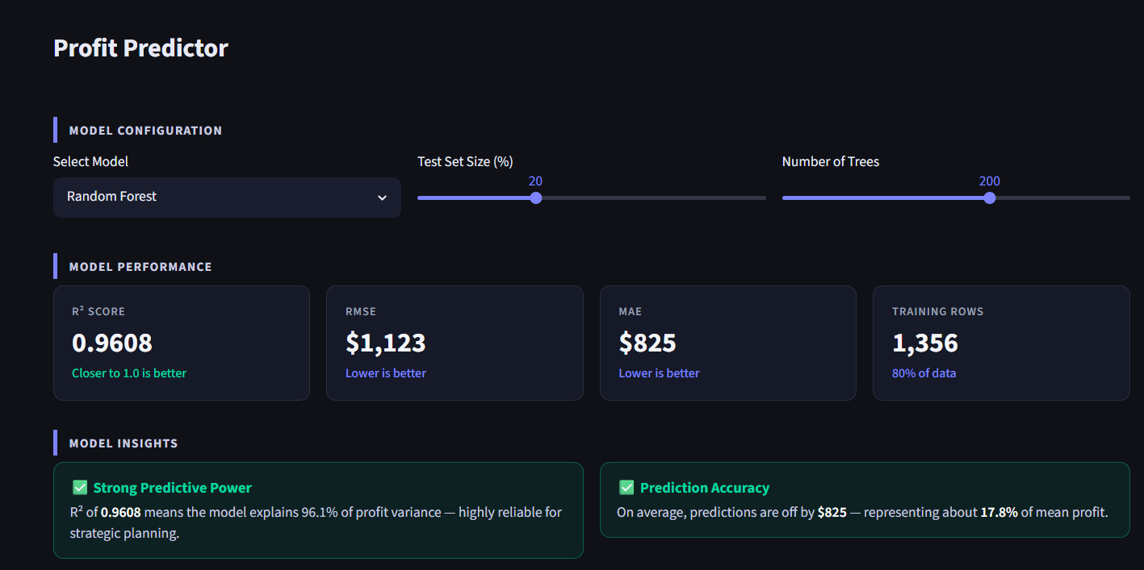
Figure 1: Random Forest model configuration and performance panel from the Profit Predictor page (R² = 0.9608, RMSE = $1,123, MAE = $825 at 200 trees; comparable figures at 100 trees are reported in Table 2).

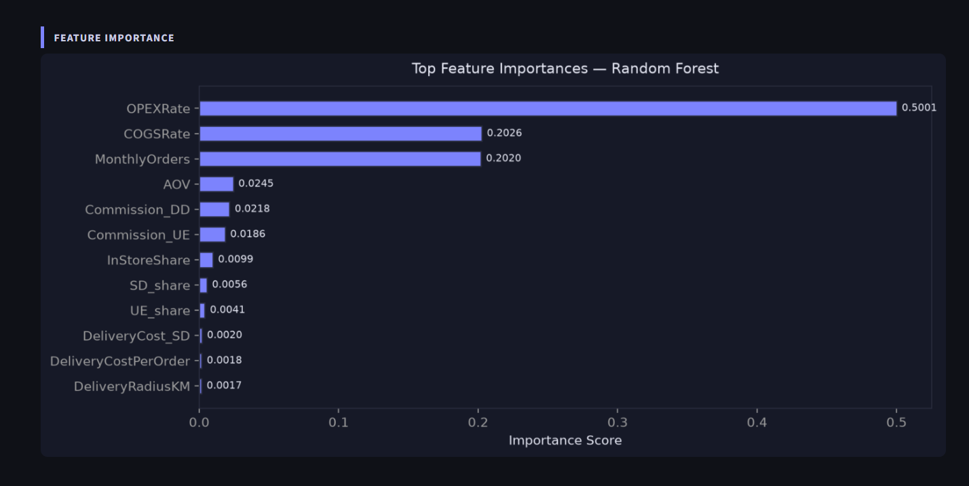
Figure 2: Top feature importances from the Random Forest model. OPEX rate alone accounts for roughly 53% of total importance.

4.2 Feature importance and confidence estimation
Feature importance from the Random Forest model (Figure 2) shows that OPEX rate dominates the prediction, accounting for over half of the total importance, followed by monthly order volume and COGS rate. Channel-mix variables and commission rates carry less weight meaningfully in the trained model than the cost-rate variables do—a pattern that recurs later in the sensitivity analysis (Section 4.5) and is one of the more actionable findings of the whole project: cost discipline moves profit more than channel strategy does, even though channel strategy is the more visible lever.

To give the live prediction a sense of its own uncertainty—something a single point estimate cannot do on its own—the dashboard computes the standard deviation of residuals on the held-out test set and reports a 90% empirical interval around each prediction (predicted value ±
1.645 standard deviations). For example, a prediction of $7,289 in monthly net profit carries a 90% interval of roughly $5,422 to $9,156. This is a simpler approach than pulling variance directly from each tree in the forest, but it is honest about what the model’s real-world error looks like on data it has not seen, rather than optimistic about how confident any one tree happens to be.

4.3 Scenario simulation engine
The What-If simulator lets a user test three categories of hypothetical change against a live baseline computed from whatever filters (cuisine, segment, and subregion) are currently applied: a Channel Mix Shift, in which the four channel-share sliders are moved away from their current values; a Commission & Cost Change, adjusting commission rate, delivery cost per order, and delivery radius; and a Growth & Demand Shift, adjusting average order value, monthly orders, and the growth factor. Each scenario reruns the trained model on the adjusted inputs and reports the resulting predicted profit alongside the dollar and percentage change from baseline so a user can directly compare “what we’re doing now” against “what happens if."

A comparison chart sweeps the commission rate from 5% to 45% in fixed increments and plots the resulting profit curve, marking the restaurant’s current commission rate against that curve. This turns an abstract sensitivity question—”How exposed are we to commission increases?"—into a single line a manager can read at a glance.
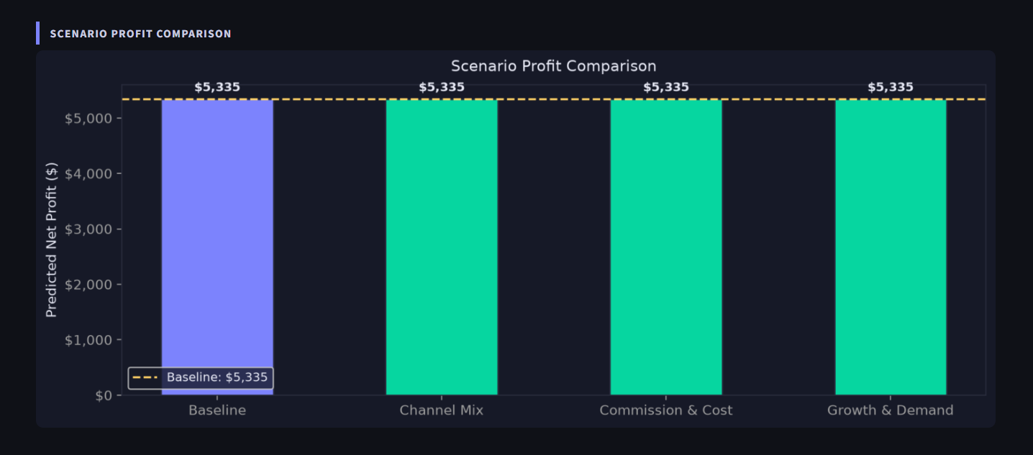
Figure 3: Scenario Profit Comparison chart from the What-If Simulator, showing predicted profit under baseline conditions against three hypothetical scenarios for a filtered subset of the portfolio (Pizza/Cafe/North Shore).

4.4 Prescriptive optimization layer
The Optimization module goes one step further than scenario testing: instead of asking the user to guess at a better channel mix and checking the result, it searches for the best one directly. The channel mix optimization is framed as a constrained non-linear program and solved with Sequential Least Squares Programming (SLSQP), maximizing predicted net profit over the four channel shares subject to the shares summing to one, a maximum commission rate the business is willing to accept, a maximum delivery cost per order, and minimum shares for one-store and self-delivery channels, reflecting the fact that a restaurant cannot realistically drop either channel to zero even if the model would otherwise recommend it. An infeasibility guard prevents the solver from being handed a constraint set that cannot be satisfied—for example, if the two minimum share constraints alone would sum to more than 95%, leaving no room for the remaining channels.

On the current filtered baseline, the optimizer converged on a recommended allocation of 35% in-store, 25% Uber Eats, 20% DoorDash, and 20% self-delivery against a current allocation of 22.6% in-store, 48.7% Uber Eats, 26.5% DoorDash, and 24.8% self-delivery. The projected result is a profit increase from $5,423 to $7,885—a 45.4% uplift—driven mainly by reducing dependence on the highest-commission channel and shifting that volume toward in-store sales, which carry no commission at all.

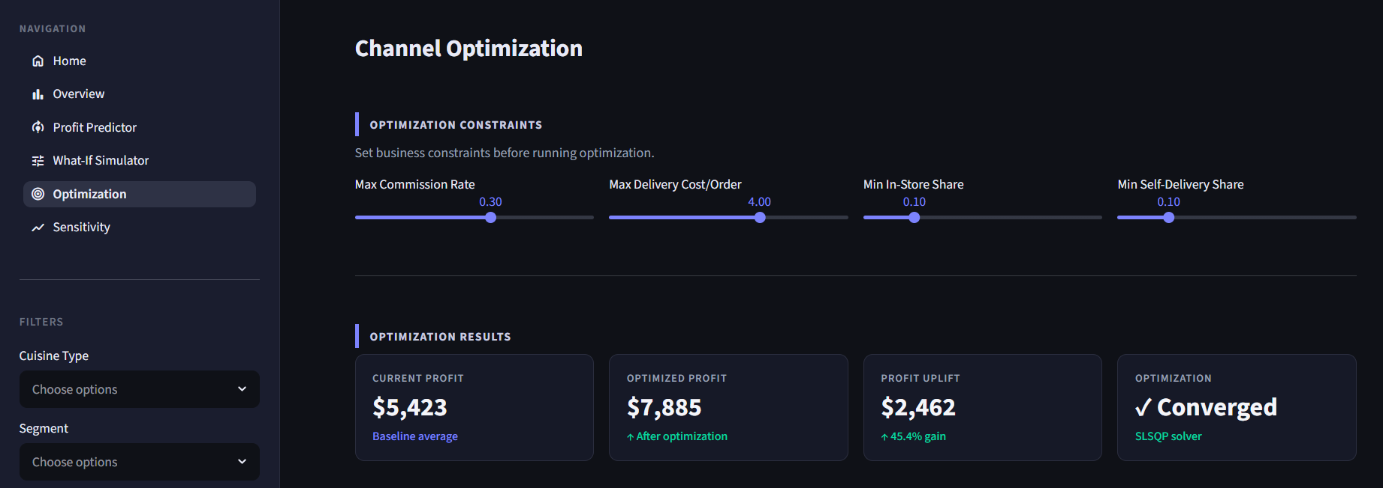
Figure 4: Channel Optimization page showing current profit, optimized profit, and resulting uplift, alongside the business constraints used by the SLSQP solver.

A break-even analysis was also run against the optimized mix, sweeping the commission rate from 5% to 50% and checking whether predicted profit ever crosses zero within that range. For the current optimized allocation, no break-even point was found: the optimized mix stayed profitable across the full tested range, which the dashboard reports as a resilience finding rather than a warning—a useful thing to know before entering a commission negotiation with a delivery partner, since it tells the business how much room it actually has.

4.5 Sensitivity analysis
The Sensitivity Analysis module answers a narrower but very practical question: of all the inputs the business could try to control, which one actually moves profit the most? For each variable, the module computes the dollar change in predicted profit resulting from a one percent change in that variable, holding everything else fixed, producing a ranked Profit Sensitivity Index.

Variable | $ Profit Change per 1% Move
OPEX Rate | $167
COGS Rate | $58
Monthly Orders | $52
Commission Rate | $40
Avg Order Value | $20
Delivery Cost/Order | $4
Delivery Radius | $1
Growth Factor | $0

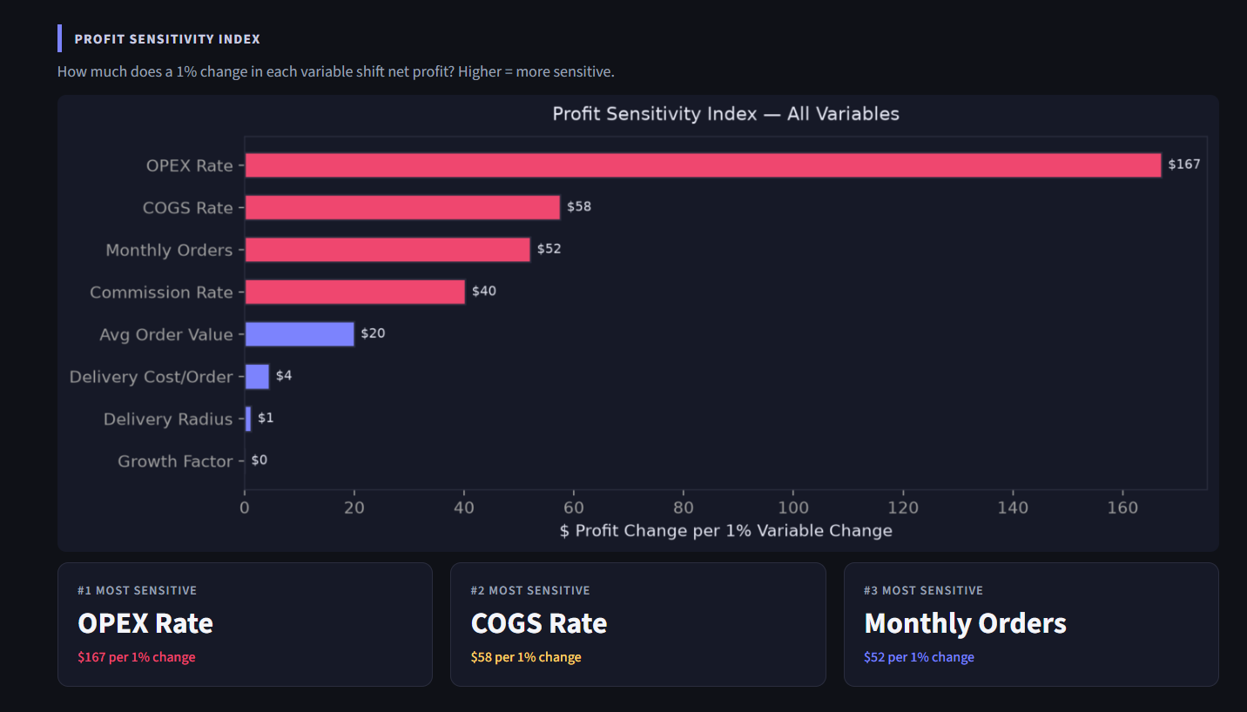
Figure 5: Profit Sensitivity Index ranking all eight decision variables by dollar impact per 1% change, with the OPEX rate the clear outlier.

The ranking is one of the more useful outputs of the whole system for a non-technical audience: OPEX rate is more than four times as sensitive as the next variable and over forty times as sensitive as delivery radius. This reframes where operational attention should go—toward controlling overhead and understanding cost-of-goods behavior—more than toward the channel mix debate that tends to dominate delivery platform conversations. A comparison variable-sweep view plots the full profit-response curve for each variable across a ± 50% range, which shows that most variables respond close to linearly around the current operating point, with OPEX rate and commission rate showing the steepest and most consequential slopes.

4.6 Per-order and channel-level profitability
Two additional metrics were added to the live predictor to close a gap between an aggregate profit number and the operational detail a manager actually needs day to day: Net Profit per Order, calculated as the predicted total profit divided by monthly order volume, and a full channel-level margin breakdown that applies the same cost logic used to build the original dataset (revenue minus COGS and OPEX, with commission subtracted for aggregator channels and delivery cost subtracted for self-delivery) to each channel individually. For the default input configuration, this produces a profit of $7.29 per order overall, with margins ranging from 37% for in-store orders down to 9.0% for Uber Eats and DoorDash orders—a gap that puts a concrete number on exactly how much commission compresses margins on aggregator channels relative to in-store sales.

4.7 Streamlit dashboard architecture
All of the above are delivered through a five-page Streamlit application rather than a static report, on the reasoning that a decision-support tool is only as useful as the number of times someone actually opens it. The pages are:

- Home — portfolio-wide KPIs (revenue, profit, margin, AOV, restaurant count), a channel performance snapshot, and a table of the top ten restaurants by net profit.
- Overview—profit by cuisine and segment, channel revenue distribution, regional performance, profit margin distribution, and a cost structure heatmap across cuisine and segment.
- Profit Predictor—model selection and configuration, live performance metrics, feature importance, and an interactive live predictor with confidence range, per-order profit, and channel margin breakdown.
- What-If Simulator—three scenario tabs (channel mix, commission and cost, and growth and demand) compared against a live baseline, plus a commission-rate sensitivity sweep.
- Optimization—constrained SLSQP-based channel mix optimizer with business-rule sliders, optimized-vs-current comparison, and break-even commission analysis.
- Sensitivity—the Profit Sensitivity Index, per-variable sweep charts, and automatically generated risk and opportunity insights.

Filters for cuisine type, business segment, and subregion apply consistently across every page, so a user can narrow the whole analysis down to, for example, just Cafe-segment Pizza restaurants on the North Shore, and every chart, KPI, and model on every page recalculates against that filtered subset.

5. Results

Taken together, the three decision-support layers point toward the same conclusion from different angles. The current portfolio is heavily weighted toward Uber Eats (48.7% of order share against a 25% share in the optimized allocation), and that overweighting is the single largest lever available to increase profit without any change to order volume, average order value, or cost rates—the optimizer’s 45.4% projected uplift comes entirely from rebalancing channels the business already has access to.

At the same time, the sensitivity analysis shows that channel mix, while the most visible lever, is not the most powerful one. The OPEX rate carries roughly four times the profit sensitivity of the commission rate, meaning that a one-point improvement in operating efficiency is worth roughly as much as a much larger swing in channel allocation. This suggests the two findings work best together rather than as competing priorities: channel mix rebalancing captures a large, one-time gain, while cost discipline on OPEX and COGS produces a smaller but compounding gain on every order, regardless of which channel it came through.

The break-even analysis adds a note of reassurance to both findings: the optimized channel mix does not introduce new fragility. It remained profitable across the entire tested commission range (5% to 50%), meaning the recommended rebalancing is not a bet that only pays off if commission rates stay low—it holds up even if a delivery partner raises rates well beyond what SkyCity currently pays.

6. Discussion and Strengths

A few things about this system are worth calling out specifically because they separate it from a one-off analysis exercise.

- It answers forward-looking questions, not just historical ones. The original data can only describe what happened last month. The scenario simulator and optimizer answer what would happen under a hypothetical and what should happen given the business’s own constraints—which are the actual questions a manager is trying to answer when they open a dashboard.
- The optimizer respects real business limits, not just the module’s preferences. Left unconstrained, a profit-maximizing model would likely recommend routing all orders through whichever channel has the thinnest margin compression, ignoring the practical reality that a restaurant needs a baseline of in-store and self-delivery presence for reasons the model was never given data on. The minimum-share constraints keep the recommendation usable rather than theoretical.
- Uncertainty is shown, not hidden. A single number (“predicted profit: $7,289”) invites more confidence than a model this size should command. Reporting a 90% interval alongside it and reporting the true model comparison table even where the chosen production model isn’t the top scorer is a more honest way to hand a model’s output to someone who has to make a real decision with it.
- The cost-sensitivity ranking is arguably the most transferable insight in the whole project. Regardless of what happens to the channel mix debate, the finding that OPEX rate dominates profit sensitivity by a wide margin is something SkyCity’s finance and operations teams can act on immediately, independent of any of the delivery-platform modeling.

7. Limitations and Future Work

The most important limitation of this work is a data leakage risk in the current feature set. The channel-share variables used as model inputs (InStoreShare, UE_share, DD_share, and SD_share) are derived from the same per-channel revenue columns that were used, alongside cost rates, to construct TotalNetProfit, the model’s target variable. Because the input and the target share a common origin, the model’s very high R² scores—particularly the 0.97 achieved by Gradient Boosting—are likely inflated relative to what the model would achieve on genuinely independent data, such as a future month the model has not seen, constructed from a different underlying process. This does not make the model’s directional findings wrong—the relationship between channel mix and profit is real and mechanical, not spurious—but it does mean the specific accuracy figures reported in Table 2 should be read as an upper bound on real-world performance rather than a number to quote unqualified in an executive setting.

A second limitation concerns the model-selection decision itself. Random Forest was chosen for production over Gradient Boosting despite scoring lower on every accuracy metric, with the reasoning that its ensemble structure supports a natural confidence interval and that it is more stable under the filtering the dashboard allows. That is a defensible engineering trade-off, but it is a trade-off, and a future iteration should either quantify the practical cost of that choice more rigorously or adopt Gradient Boosting with a separate variance-estimation method (such as quantile regression or a bootstrap ensemble) layered on top.

Third, the guide for the project called for net profit per order and channel-level margin to exist as first-class predicted targets and for the live predictor to expose confidence bands. In the current implementation, these are computed as derived quantities from the single trained profit model and its residual distribution, rather than as outputs of dedicated models trained specifically to predict them. This is a reasonable simplification given the size of the dataset and the shared cost structure underlying all four metrics, but a version of this system with a larger dataset could train separate models per channel and compare their predictions against the derived figures used here.

Future work beyond addressing these three points includes retraining the model on a future data collection where the leakage-prone features are either removed or replaced with a variable constructed independently of the profit target (for example, planned rather than realized channel share); extending the optimizer to account for seasonality, since the current GrowthFactor variable is treated as a static input rather than a modeled time-series effect; and validating the optimizer’s recommendations against a small controlled pilot at a subset of restaurants before rolling any specific channel mix change out portfolio-wide.

8. Conclusion

This project set out to replace a static, backward-looking view of channel profitability with something a manager could actually use to make a forward-looking decision. The resulting system trains and compares three regression models on 1,696 restaurant records; selects a Random Forest model for production based on stability and interpretability rather than raw accuracy alone; and uses that model to power a scenario simulator, a constrained channel mix optimizer, and a sensitivity analysis—all delivered through an interactive five-page dashboard rather than a one-time report.

The headline finding—that rebalancing away from Uber Eats towards in-store sales could lift profit by 45.4%—is one a restaurant group can act on directly. The quieter but arguably more durable finding—that OPEX rate matters roughly four times more to profit than commission rate does—is one that holds regardless of what happens with any single delivery partner. Reporting both, alongside the model’s own uncertainty and a transparent account of where the current features set has a leakage risk, was the goal throughout: a decision-support tool is only worth building if the people using it can trust what is and is not telling them.

9. References

Breiman, L. (2001). Random Forests. Machine Learning, 45(1), 5-32. https://doi.org/10.1023/A:1010933404324

Kraft, D. (1988). A software package for sequential quadratic programming. DFVLR-FB 88-28, DLR German Aerospace Center—Institute for Flight Mechanics, Cologne, Germany.

Pedregosa, F., et al. (2011). Scikit-learn: Machine learning in Python. Journal of Machine Learning Research, 12, 2825-2830.

Unified Mentor. (2026). SkyCity Auckland Restaurant & Bars: Project brief and dataset. Internal document.

Acknowledgement
I thank Unified Mentor for providing the SkyCity Auckland dataset and for supporting this research paper as part of the Data Analyst Internship program.

